**Lecture 01**

* ECMAScript are standardized versions of Javascript.
* Javascript is interpreted language i.e its instructions are executed line by line.
* The other kind of languages are compiled languages in which the program is compiled as a whole and then executed.

**Lecture 02**

**Lecture 03**

**Lecture 04 (JavaScript variables)**

* You can declare a variable in javascript using the following syntax.



* Always give your variables meaningful names.
* In javascript we name variables like this myVar. This is called camel-casing variables i.e. every variable starts with a small letter and next word will be a capital letter like “myFirstName”.

**Lecture 05**

**Lecture 06**

**Lecture 07**

**Lecture 08 (Slicing strings)**

* The slice function works like var.slice (lowerbound, upperbound). Here lower bound is inclusive while upper bound is not inclusive.

**Lecture 09**

* You can use the var.toUpperCase() to change lower case elements to upper case elements.
* You can also use the function var.toLowerCase() to change upper case characters to lowercase.

**Lecture 10**

**Lecture 11**

**Lecture 12**

**Lecture 14 (Functions in Javascript)**

* The syntax for functions is

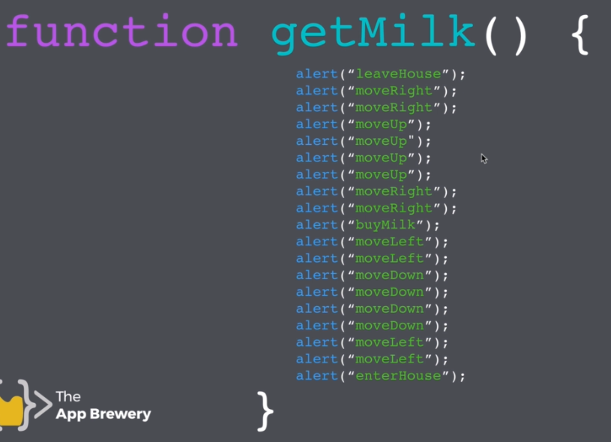

* Here getMilk is function name and the code enclosed within {} is the instruction issued in the functions.
* You can pass arguments in functions like this

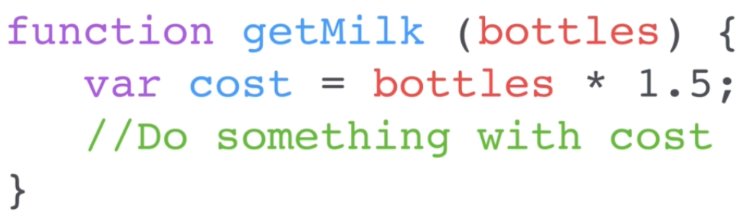

**Lecture 15**

**Lecture 18**

**Lecture 19**

**Lecture 20**

**Lecture 22**